Problem Set #12: Simple Linear Regression
- Answer the following question on the basis of the SPSS output below which was generated from a regression analysis examining the relationship between anxiety and mistakes made during an honors thesis defense (this was an example we looked at during the correlation chapter).
  - What was the regression equation relating anxiety to mistakes?
  - Was anxiety a significant predictor or mistakes?
  - How much of the variance in mistakes could be attributed to variability in anxiety?
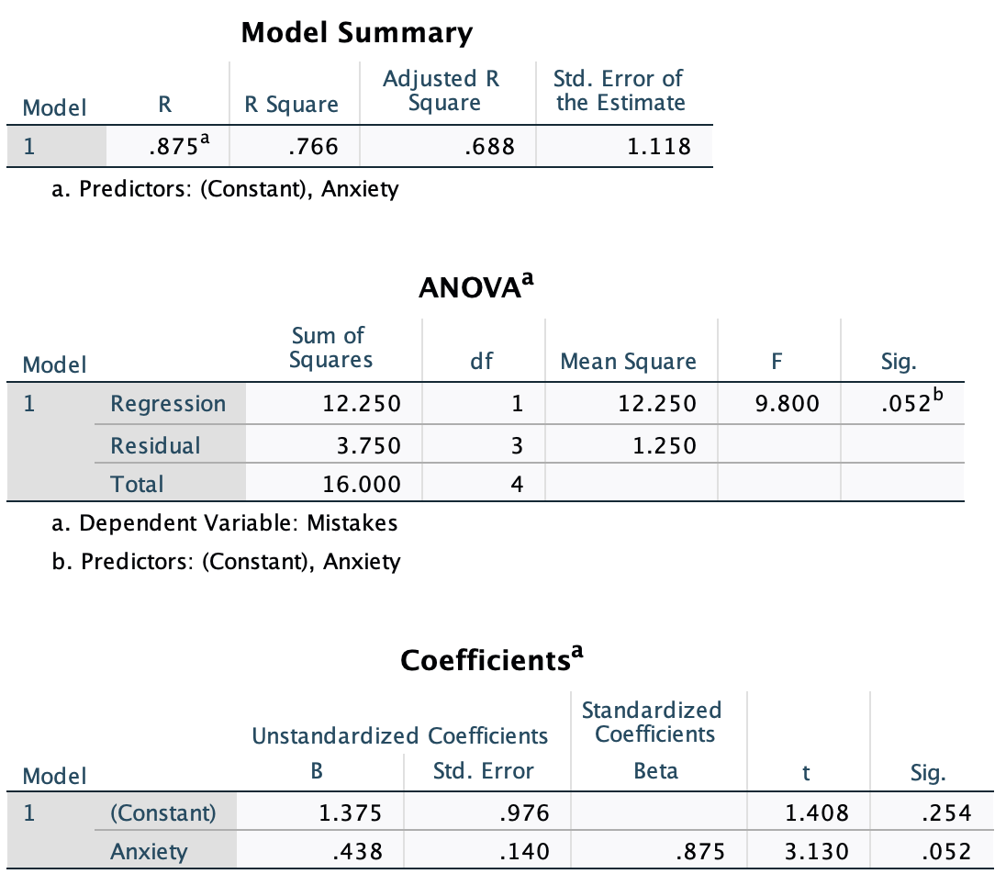
- You and Buster were sitting around one weekend evening, sipping on some age-appropriate refreshments (i.e. “Beer”). You noticed that as you drank more and more refreshments, your need to visit the bathroom (BR) increased. What are you going to do? You decide to collect some data. The table below presents information on a randomly selected sample of students for whom two pieces of data were collected: the number of refreshing beverages consumed in an evening, and the number of trips to the BR. Use these data to perform the following calculations:
X (beers) | Y (trips to the BR) | X² | Y² | X*Y
3 | 0
4 | 2
5 | 5
5 | 5
4 | 6
7 | 8
4 | 2
6 | 4
5 | 3
7 | 5
  - What is the linear regression relating beer consumption and trips to the BR?
  - How many trips to the BR would you predict someone would make if they consumed 5 beers?
  - Could you make a prediction for someone who drank a 12-pack? Explain.
  - Is the y-intercept an interpretable value? If so, what does it suggest?
  - Perform an ANOVA (not correlation) hypothesis test to determine whether the number of beers consumed is a significant predictor of trips to the BR.
  - How much of the variance in trips to the BR can be explained by beer consumption?
  - Feel free to create an SPSS file to check your answers to parts a-e.

