Problem Set #14: Multiple Regression
- Answer the following question on the basis of the SPSS output below which was generated from a multiple regression analysis examining the relationship between friendship quality and a variety of predictors. The subjects were asked to rate the quality of their friendship (e.g., how close they felt to the friend) along with several measures of similarity including: similarity of experiences, interests, and personality. The subjects also indicated how long they have been friends with the person (length) and whether they felt they could rely on their friend when they needed help (reliability).
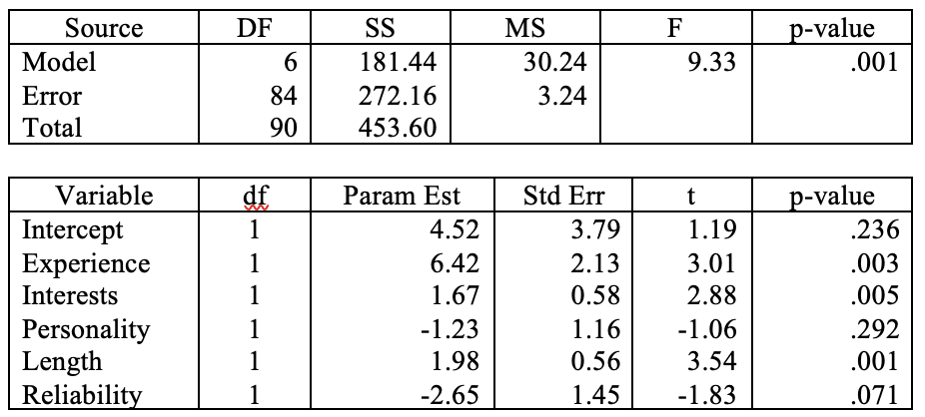
  - What is the regression equation relating friendship quality to the predictor variables?
  - What are the significant predictors of friendship quality?
  - Would you be concerned if you found that there was a high correlation between Interests and Personality? Explain.
  - How much of the variance in friendship quality could the model explain?
  - Which factor(s) would you recommend removing from the model?
  - Let’s assume that the regression analysis was re-conducted after removing the factors that you identified in response to question e). r² for the reduced model dropped to .378. Would you keep this original model or adopt the simpler reduced model even though it explained less of the variance in friendship quality? Explain.

