Problem Solving
________________________________________

1) Explore different kinds of problems and break down the basic anatomy of a problem.

2) Look at methods for successful problem solving and strategies that impede successful solutions.

3) Discuss three important issues related to problem solving:
- Transfer
- Incubation
- Insight

4) Examine personality characteristics/individual differences related to problem solving:
- Talent
- Creativity
- Expertise
Types of Problems
_______________________________________

Well-defined - problems with a limited set of inputs and operations that have a definite answer and a definite solution procedure.
EX: algebra problems

Fuzzy - problems with a functionally infinite set of inputs and operations with no obvious definite solution or best answer.
EX: psychology exam

Everyday problems:
I need to get to the bank, and the grocery store, mail my phone bill, go to class and show up for my job at 2:00. How can I get all of these things done?

Natural progression
- Theory vs. application
- Inside vs. outside the lab
- Across your educational career

Anatomy of a Problem
___________________________________________

Beginning State - the set of information given at the beginning; the state of affairs before any attempt to solve the problem is made.

Problem Space - a listing of all the relevant elements, procedures and rules for solving a problem

Goal State - the definition of what constitutes a successful solution to the problem.

Characteristics of problem solving
- Goal Directedness
- Sequence of steps
- Cognitive operations
- Subgoal decomposition
General Problem Solving Strategies
___________________________________________

Difference Reduction Method - create a number of attainable subgoals that will reduce the difficulty of the task to a series of manageable steps.
EX: cannibal missionary problem

Generate/Test - Generate a potential solution; see how well it works.
EX: professor's age

Alternative Representations - try describing the problem space in a different modality (e.g., visual instead of verbal)
EX: Monk-Mountain problem
Army-Cannon Problem

Solution Reversal - start at the end state and try to work your way back to the beginning state.
EX: Ten Pennies

Means-end analysis - create a subgoal that will allow a certain operator to become useful.
EX: Sultan the Monkey
What makes problem solving hard?
___________________________________________

Repeat State Avoidance - bias against returning to an earlier state; sometimes you have to go backwards in order to go forwards
EX: football vs. soccer
Cannibal / Missionary
Tower of Hanoi

Difference reduction - bias to make the move that will have the greatest affect on the distance to the goal state.
EX:
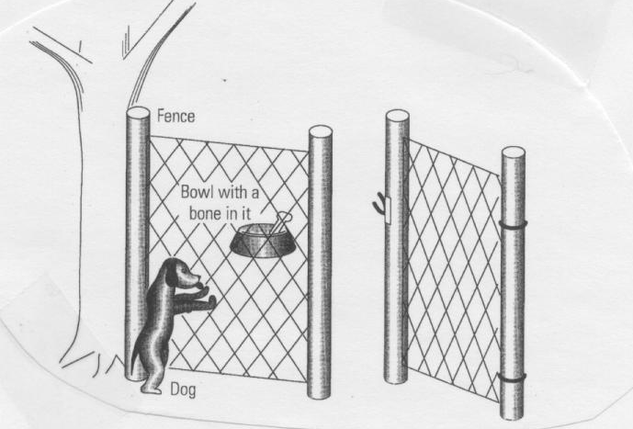
Difference reduction issues: People
______________________________________________

C O L D
__ __ __ __
__ __ __ __
__ __ __ __
W A R M
______________________________________________

F A L L
__ __ __ __
__ __ __ __
__ __ __ __
C O L D
More Impediments to Problem Solving:
Persistence of Set
___________________________________________

You have three jugs and a faucet. Use the jugs to create the target volume of water.

A | B | C | Target
21 | 127 | 3 | 100
14 | 163 | 25 | 99
18 | 43 | 10 | 5
9 | 42 | 6 | 21
20 | 59 | 4 | 31
23 | 49 | 3 | 20

Solve these Anagrams
hcsip rbkoo ugeid hcfie rfhes tseal

Even more Impediments to Problem Solving:
Functional Fixedness
___________________________________________

Dot problems

. . . .

. . . .

. . . .

. . . .

Match Problem
You have six matches. Arrange them such that you create 4 equilateral triangles with each side equal to the length of one match.
Even more Impediments to Problem Solving:
Functional Fixedness
______________________________________________

Using just the materials shown here, can you construct a hat rack in the room shown in this figure?

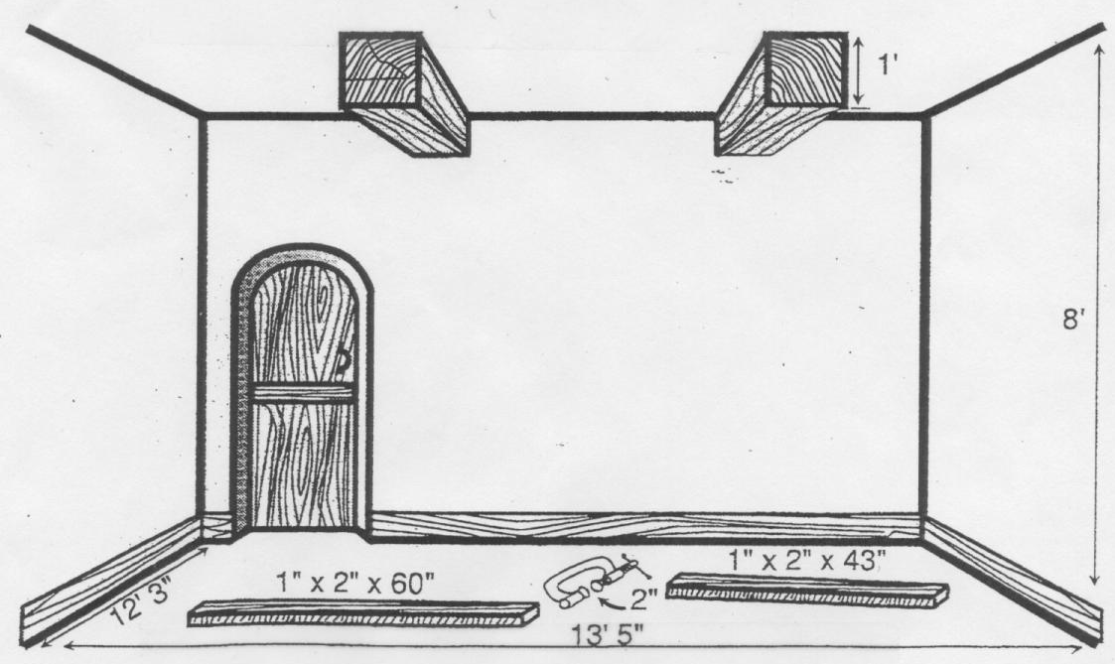
Which of these games would be easiest to win?
______________________________________________

1) A set of cards showing the integers 1-9 are placed face up between two players. The goal of the game is to be the first to hold three cards bearing integers that sum to 15 (you are not limited to three cards, but three of your cards must sum to 15). If neither player satisfies these conditions, the game is declared a draw, the cards are replaced on the table, and the game begins anew.

2) Tic-Tac-Toe

3)
6 | 1 | 8
7 | 5 | 3
2 | 9 | 4
Each player chooses a square. The first player who completes a horizontal, vertical, or diagonal line that sums to 15 wins. If neither player wins, the game is a draw and play starts over.
Analogical Transfer
___________________________________________

How well do we extract relevant information from an example and use it to solve future problems?

Depends on two factors:

Structural similarity - similar to deep structure

Surface similarity - similar to surface structure

Gick and Holyoak (1980)
___________________________________________

Lightbulb story: Biff broke the filament of a lightbulb in the physics lab where he works. A single high-energy laser [ultrasound wave] would fix the filament, but would break the glass of the bulb [would be too weak to fix the filament]? How can Biff fix the bulb?

Tumor story: A patient has a tumor that is inoperable by standard means. A high intensity laser beam would destroy the tumor, but would also destroy too much of the surrounding tissue. How can the patient be saved?
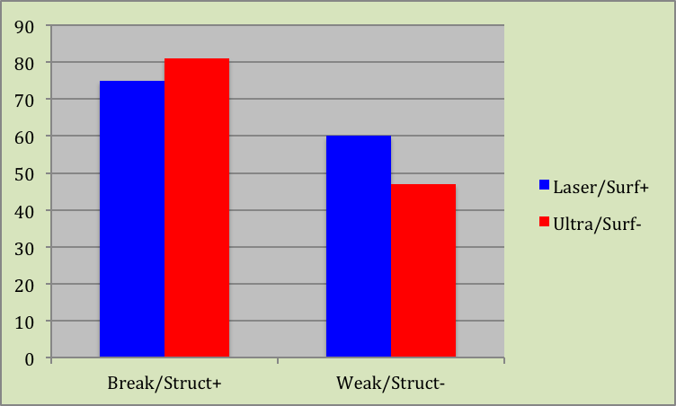
Gick and Holyoak (1980)
___________________________________________

 | Laser  (HiSurf) | Ultra  (LoSurf)
Break Glass  (HiStruct) | 75 | 81 | 78
Too weak  (LoStruct) | 60 | 47 | 54
 | 68 | 64

Incubation
________________________________________

Incubation - when all else fails, set the problem aside for a while and do something else.
EX: crossword puzzles

Why does incubation work?
- decay of less important details
- consolidation
- new stimuli may activate different perspectives
- new problem enables analogical transfer
- when cognitive arousal is low, a larger number of more remote cues can become activated leading to a problem solution

Ways to make incubation work for you:
- try hard before setting the problem aside
- be patient; not good if working on a deadline
- REALLY STOP THINKING ABOUT IT!

Insight Problems
___________________________________________

Insight Problem - a problem for which the solution requires the solver to dramatically re-conceptualize some aspect of the problem.

Example #1: A prisoner was attempting to escape from jail. He found a rope that was half as long as he needed to slide out of his cell window and down to safety. He divided the rope in half and tied the two parts together and escaped. How did he do it?

Example #2: You have 4 links of chain. It costs two cents to open a link and three cents to close the link back up. Your goal is to join all 12 links into a single circle at a cost of no more than 15 cents.

Example #3: Move three pennies to form a triangle pointing in the opposite direction.

Nature of insight
_______________________________________

Selective encoding - learn what to pay attention to and what to ignore

Selective comparison - learn how two pieces of seemingly separate information actually relate to one another.

Selective combination - learn how to combine pieces of information into a unified representation.

Metcalfe and Wiebe (1987)
______________________________________________

Theoretical Question: Can we create a theoretical distinction between insight and noninsight problems?

Empirical Question: How would metacognitive behavior differ for insight vs. noninsight problems?
- What is metacognition?
- Why is insight so difficult to study?

Method:
- Solved insight and noninsight problems
- Gave warmth ratings and expectations / predictions regarding whether a problem would be solved correctly

Results:
- Expectations / predictions were more accurate for noninsight problems
- Large changes in both incremental and angular warmth ratings were associated with insight problems
Metcalfe and Wiebe’s data: Warmth Ratings
______________________________________________

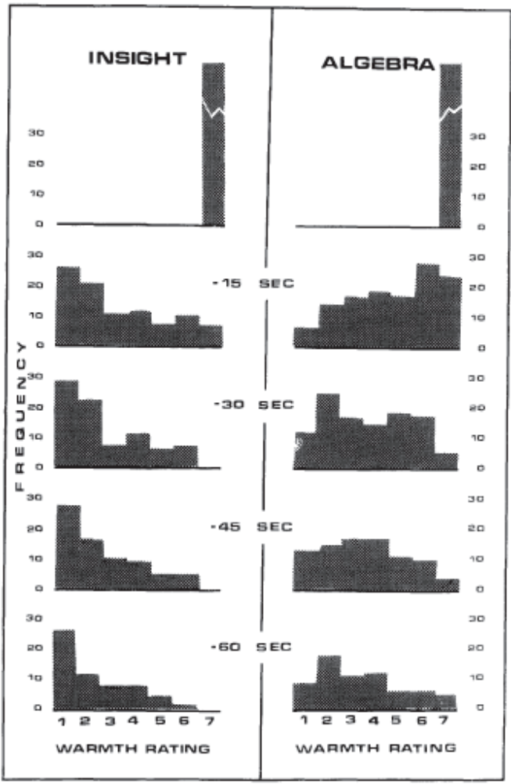
Metcalfe and Wiebe’s Interpretation
______________________________________________

Interpretation:
- Metacognitive experience can distinguish insight from noninsight problems

Discussion:
- What was the difference between Exp. 1 and Exp. 2? Why were both included in the paper?

- What is the difference between personal and normative predictions of success? Why might they differ? What do the data related to this analysis mean?
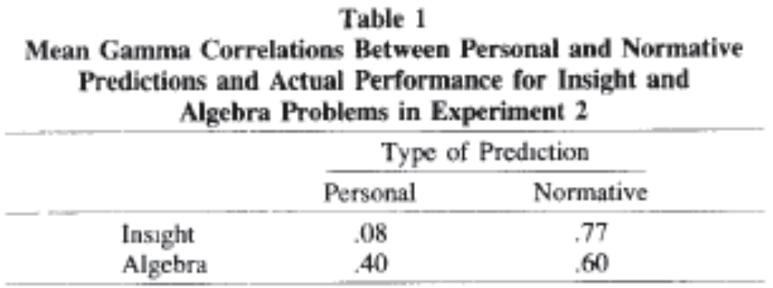

- What are some other possible interpretations for the results of the experiments?
Talent
___________________________________________

What determines success?
- Practice makes perfect
or
- Some people born with an ability (a talent) to perform certain tasks?

Genes do matter
- Parents who read well have kids who read well (and vice versa)
- I was never in any danger of playing a sport professionally.

But, you can always get better.
Creativity
___________________________________________

What makes one creative?

a) Amount of ideas one produces
I give you a problem and ask you to create as many solutions as you can think of. I measure diversity, numerosity and appropriateness of your responses

b) It’s what you know
Creative people study their domain more, so they know more, and therefore, can produce more valuable and new ideas by combining and reshaping what they already know.

c) It’s who you are
openness to new ideas, new ways of thinking and seeing the world; intrinsic motivation

d) It’s where you are
your environment (parents) and social, scientific, and artistic communities in which you are raised all play a role

